## CS 3340 Computer Architecture – Spring 2019 – Mazidi

## Homework 5: BMI Calculator

Objective: To gain proficiency in coding MIPS floating-point operations.

### Instructions

Write a MIPS program that calculates bmi. Use the following C++ code as pseudocode. The variable **bmi** can be single or double precision.

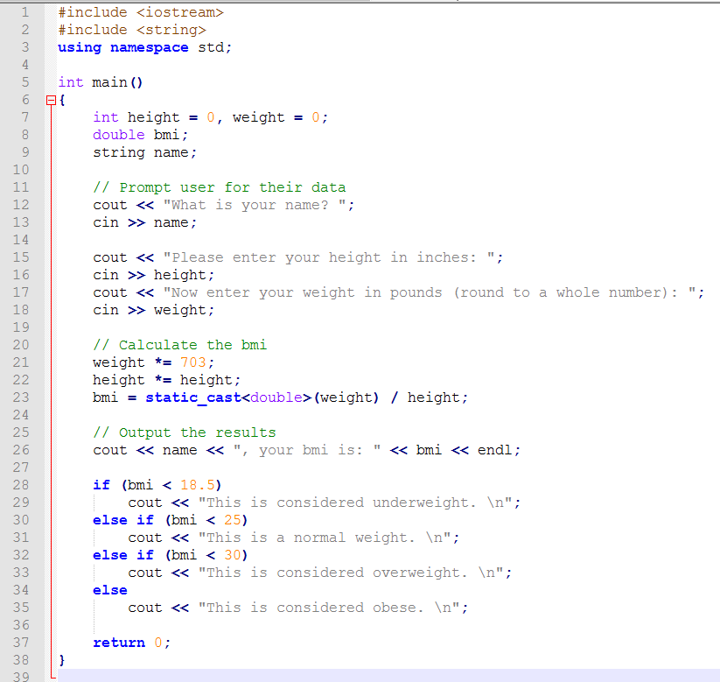

Grading Rubric:

90 points – working code

10 points – input height and weight from user using SYSCALLS

40 points – calculate bmi

10 points – echo bmi to user using SYSCALLS

30 points – “if” statements determining weight category

and output message to user using SYSCALL

10 points – comments in the code

***Upload your .asm file to eLearning***